Answer Key

Part - A
(10 x 1 = 10 Marks)
Instructions: Answer all
Q. No | Question | Marks | BL | CO | PO | PI Code
1 | What is the worst-case complexity of bubble sort?  a) O(nlogn)  b) O(logn)  c) O(n)  d) O(n²) | 1 | 1 | 1 | 1 | 1.1.1
2 | The given array is arr = {1, 2, 4, 3}. Bubble sort is used to sort the array elements. How many iterations will be done to sort the array?  a) 3  b) 2  c) 1  d) 0 | 1 | 4 | 1 | 2 | 1.1.1
3 | What is the best case and worst case complexity of ordered linear search?  a) O(nlogn), O(logn)  b) O(logn), O(nlogn)  c) O(n), O(1)  d) O(1), O(n) | 1 | 1 | 1 | 1 | 1.3.1
4 | What is the average number of inversions in an array of N distinct numbers while performing bubble sort?  a) N(N-1)/4  b) N(N+1)/2  c) N(N-1)/2  d) N(N-1)/3 | 1 | 3 | 1 | 2 | 1.1.1
5 | What is the running time of an insertion sort algorithm if the input is pre-sorted?  a) O(N²)  b) O(N log N)  c) O(N)  d) O(M log N) | 1 | 2 | 1 | 2 | 1.1.1
6 | What is the advantage of recursive approach than an iterative approach?  a) Consumes less memory  b) Less code and easy to implement  c) Consumes more memory  d) Easy to test and debug during iteration | 1 | 4 | 1 | 1 | 1.1.1
7 | What is the best case time complexity of the binary search algorithm?  - O(1)  - O(n)  - O(nlogn)  - O(n²) | 1 | 4 | 1 | 2 | 1.3.1
8 | ___of an algorithm is the amount of time required for it to execute.  a. Time complexity  b. Space complexity  c. Compiling time  d. Best case | 1 | 3 | 1 | 2 | 1.1.1
9 | ___ within the limit deals with the behavior of a function for sufficiently large values of its parameter.  a. Asymptotic notation  b. Big-Oh notation  c. Omega notation  d. Theta notation | 1 | 2 | 1 | 1 | 1.1.1
10 | void solve() {  string s = "scaler";  int n = s.size();  for(int i = 0; i < n; i++) {  s = s + s[i];  }  Find the time complexity of the above code segment  - O(1)  - O(n)  - O(n^2)  - O(logn) | 1 | 3 | 1 | 2 | 1.3.1
Part – B
( 5 x 3 = 15 Marks)
Instructions: Randomly selected three questions. Answer any three Questions
11 | Evaluate the following recurrence relation. T(n) = 9T(n/3) + 4n⁶, n>=3 | 5 | 3 | 1 | 2 | 1.3.1
12 | Solve the recurrence relation using recursion tree. T(n)=2T(n/2)+cn | 5 | 4 | 1 | 2 | 1.3.1
13 | (i) How to write an efficient algorithm? What are the design techniques to be considered? (3)  (ii) Define Theta Notation. Provide its graphical representation. (2) | 5 | 1 | 1 | 1 | 1.1.1
14 | Show that the solution of (i) T(n)=T(⌈n/2⌉)+1 is O(logn). (3)  ii)T(n)=T(n−1)+n is O(n^2) use the substitution method (2) | 5 | 3 | 1 | 2 | 1.3.1

12.

- 13.
A finite set of steps that must be followed to solve any problem is called an algorithm. Algorithm is generally developed before the actual coding is done. It is written using English like language so that it is easily understandable even by non-programmers.
- Promotes effective communication between team members
- Enables analysis of problem at hand
- Acts as blueprint for coding
- Assists in debugging
- Becomes part of software documentation for future reference during maintenance phase
These are the characteristics of a good and correct algorithm −
Has a set of inputs
Steps are uniquely defined
Has finite number of steps
Produces desired output

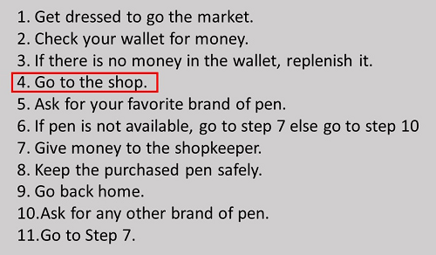

Brute-Force Search, Divide and Conquer, Greedy Algorithm, Dynamic Programming
Branch and Bound Algorithm, Randomized Algorithm, Backtracking Algorithms.

14.

Part - A
(10 x 1 = 10 Marks)
Instructions: Answer all
Q. No | Question | Marks | BL | CO | PO | PI Code
1 | A ______________is much more valuable than a thousand tests.  - Proof of correctness  - Performance measurement  - Profiling  - Debugging | 1 | 2 | 1 | 1 | 1.1.1
2 | ________criteria denote that each step in an algorithm must be such that it can, at least in principle, be done by a person using pencil and paper in a finite amount of time.  - Finiteness  - Definiteness  - Effectiveness  - Ambiguous | 1 | 1 | 1 | 1 | 1.1.1
3 | ___________ refers to the task of determining how much computing time and storage an algorithm requires.  - Algorithm analysis  - Time analysis  - Space analysis  - Asymptotic Notation | 1 | 1 | 1 | 1 | 1.1.1
4 | ___ notation is useful for expressing the lower bound of the complexity function  - O big oh  - Ω big omega  - Θ theta notation  - o little oh | 1 | 2 | 1 | 2 | 1.1.1
5 | ___ of an algorithm is the amount of time required for it to execute.  a. Time complexity  b. Space complexity  c. Compiling time  d. Best case | 1 | 2 | 1 | 1 | 1.3.1
6 | Which one is the correct order of increasing growth?  a. O(1), O(log n), O(log log n), O((log n)^2)  b. O(1), O(log log n), O((log n)^2), O(log n)  c. O(1), O(log log n), O(log n), O((log n)^2)  d. O(1), O(log n), O((log n)^2), O(log log n) | 1 | 4 | 2 | 1 | 1.3.1
7 | If an algorithm has the running time as a recurrence equation then the algorithm is ____  - Non-recursive  - Iterative  - Recursive  - Infinite | 1 | 1 | 1 | 1 | 1.1.1
8 | The measure of the longest amount of time possibly taken to complete an algorithm is expressed as __.  a. Little-O  b. Little-Omega  c. Big-Omega  d. Big-O | 1 | 2 | 1 | 2 | 1.1.1
9 | What is the best case running time of bubble sort? Choices are the same.  a) O(N²)  b) O(N log N)  c) O(N)  d) O(M log N) | 1 | 3 | 1 | 2 | 1.1.1
10 | What is the best case and worst case time for inorder traversal of balanced binary search tree?  a. O(log n), O(n)  b. O(n), O(log n)  c. O(log n), O(log n)  d. O(n), O(n) | 1 | 4 | 1 | 2 | 1.3.1
Part – B
( 5 x 3 = 15 Marks)
Instructions: Randomly selected three questions. Answer any three Questions
11 | Define the terms Best case, Worst case, and Average case time complexities with example | 5 | 1 | 2 | 1 | 1.1.1
12 | Solve the recurrence using recursion tree method:  T(1) = 1  T(n) = T(n-1) + n n>0 | 5 | 3 | 2 | 4 | 1.1.1
13 | Give short note on the Fundamentals of Algorithmic Problem Solving.  Discuss the steps involved Bubble sort algorithm with time complexity | 5 | 3 | 1 | 2 | 1.3.1
14 | Show that the solution of the recurrence T(n) = T(n/2) + lg n is O((log n)²) using substitution method. | 5 | 4 | 2 | 2 | 1.3.1

Part – B
11.
The worst, average, and best case of an algorithm depends on the size of the user input value. In the worst-case analysis, we calculate the upper limit of the execution time of an algorithm.
It is necessary to know the case which causes the execution of the maximum number of operations
For linear search, the worst case occurs when the element to search for is not present in the array. When x is not present, the search () function compares it with all the elements of arr [] one by one. Therefore, the temporal complexity of the worst case of linear search would be Θ (n).
Average Case Analysis:
In the average case analysis, we take all possible inputs and calculate the computation time for all inputs. Add up all the calculated values ​​and divide the sum by the total number of entries.
We need to predict the distribution of cases. For the linear search problem, assume that all cases are uniformly distributed. So we add all the cases and divide the sum by (n + 1).
Best Case Analysis:
In the best case analysis, we calculate the lower bound of the execution time of an algorithm. It is necessary to know the case which causes the execution of the minimum number of operations. In the linear search problem, the best case occurs when x is present at the first location.
The number of operations in the best case is constant. The best-case time complexity would therefore be Θ (1) Most of the time, we perform worst-case analysis to analyze algorithms. In the worst analysis, we guarantee an upper bound on the execution time of an algorithm which is good information.

12. T(n) = T(n-1) + n
= T(n-2) + n-1 + n
= T(n-3) + n-2 + n-1 + n
// we can now generalize to k
= T(n-k) + n-k+1 + n-k+2 + ... + n-1 + n
// since n-k = 1 so T(1) = 1
= 1 + 2 + ... + n //Here
= n(n-1)/2
= n^2/2 - n/2
// we take the dominating term which is n^2*1/2 therefor 1/2 = big O
= big O(n^2)
13.
A finite set of instruction that specifies a sequence of operation is to be carried out in order to solve a specific problem or class of problems is called an Algorithm.
Input: It should externally supply zero or more quantities.
Output: It results in at least one quantity.
Definiteness: Each instruction should be clear and ambiguous.
Finiteness: An algorithm should terminate after executing a finite number of steps.
Effectiveness: Every instruction should be fundamental to be carried out, in principle, by a person using only pen and paper.
Feasible: It must be feasible enough to produce each instruction.
Flexibility: It must be flexible enough to carry out desired changes with no efforts.

14.
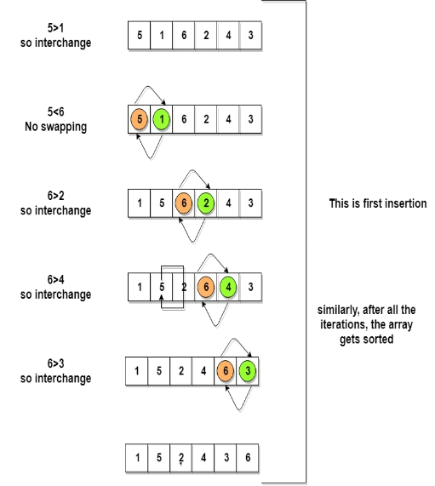
Complexity Analysis of Bubble Sort
In Bubble Sort, n-1 comparisons will be done in the 1st pass, n-2 in 2nd pass, n-3 in 3rd pass and so on. So the total number of comparisons will be
(n-1) + (n-2) + (n-3) + ..... + 3 + 2 + 1
Sum = n(n-1)/2
i.e O(n²)
time complexity of Bubble Sort is O(n²).
The main advantage of Bubble Sort is the simplicity of the algorithm.
The space complexity for Bubble Sort is O(1), because only a single additional memory space is required i.e. for temp variable.
Also, the best case time complexity will be O(n), it is when the list is already sorted.
Following are the Time and Space complexity for the Bubble Sort algorithm.
- Worst Case Time Complexity [ Big-O ]: O(n²)
- Best Case Time Complexity [Big-omega]: O(n)
- Average Time Complexity [Big-theta]: O(n²)
- Space Complexity: O(1)

